Hospital: Confluence
Presenter: Khoa Nyguen
Question/case summary:
Pt with ESRD on hemodialysis who presented with confusion. UA and Urine culture obtained – grew and unusual GNR (sensitive to ceftriaxone and cefazolin) - started on ceftraixone.
We were debating about switching to a PO option such as either cefpodoxime or even cephalexin; however, as this is a HD patient, we unsure if this would be effective for a cystitis.
There was concern that an agent that is normally renally cleared will not accumulate adequate levels in the urinary tract and thus might not be effective for treatment in an HD pt. We decided to leave ceftriaxone for 5 days total in the end.
Although there are renal dosing adjustments for say cephalexin, my understanding is that those mainly help reduce build up of toxic serum levels. So if you're on dialysis and have minimal renal function, would something like cephalexin still be able to build a sufficient concentration in the urinary tract to treat a cystitis like ceftriaxone?

UW TASP Recommendations:

Regarding treatment: The first line and second line UTI treatments will still work in ESRD patients. GFR may be significantly reduced but antibiotics will get to the site of infection via the circulatory system. The exception is nitrofurantoin, which requires active renal secretion to achieve effective therapeutic concentrations. This agent should be avoided.

As far as the appropriateness of treatment in the first place, cystitis is a questionable diagnosis in ESRD/HD patients. A review of alternative causes is appropriate, i.e. metabolic acidosis, other medications, particularly if the patient is altered.

In a 6-year retrospective review of ESRD patients on HD with bacteriuria, only 30% had clinical symptoms. 65% were prescribed antibiotics. In a regression analysis of readmission rate, antibiotics made no difference in readmission: 50% readmitted who received antibiotics and 50% readmitted who didn’t received antibiotics (P = 1). Nine patients (13%) developed CDI within 6 months of the episode of bacteriuria.
https://www.ncbi.nlm.nih.gov/pmc/articles/PMC5898183/
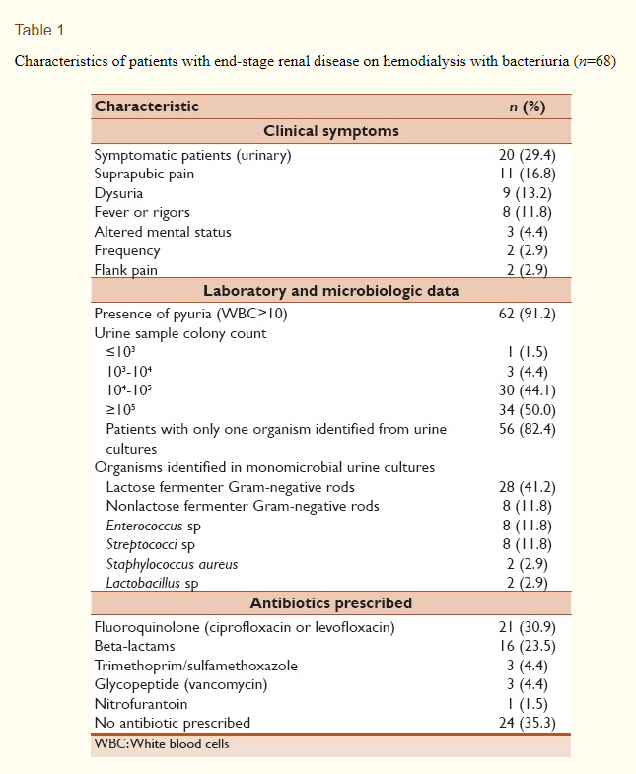

Additionally, the IDSA offers new guidelines for asymptomatic bacteriuria which may be relevant here. “In older patients with functional and/or cognitive impairment with bacteriuria and delirium (acute mental status change, confusion) and without local genitourinary symptoms or other systemic signs of infection (eg, fever or hemodynamic instability), we recommend assessment for other causes and careful observation rather than antimicrobial treatment (strong recommendation, very low-quality evidence).”³

References
- Taweel I et al. Significance of bacteriuria in patients with end-stage renal disease on hemodialysis Avicenna J Med. 2018 Apr-Jun; 8(2): 51–54. doi: 10.4103/ajm.AJM_199_17
- Gilbert DN. Urinary tract infections in patients with chronic renal insufficiency. CJASN 2006;1(2):327.
- Nicolle LE, Gupta K, Bradley SF, Colgan R, DeMuri GP, Drekonja D, Eckert LO, Geerlings SE, Köves B, Hooton TM, Juthani-Mehta M. Clinical practice guideline for the management of asymptomatic bacteriuria: 2019 update by the Infectious Diseases Society of America. Clinical Infectious Diseases. 2019 Mar 21;68(10):e83-110.

On behalf of the UW TASP Specialist Team:

John Lynch, MD MPH
Chloe Bryson-Cahn, MD
Jeannie Chan, PharmD
Zahra Kassamali Escobar, PharmD
Rupali Jain, PharmD
Paul Pottinger, MD FIDSA

PLEASE NOTE that UW TASP case consultations do not create or otherwise establish a provider-patient relationship between any UW Medicine Health Care Professional and any patient whose case is being presented in a UW TASP setting. A provider-patient relationship between a UW Medicine Health Care Professional and a patient whose case was presented at UW TASP may later be established if the patient is referred and seen in the context of a regular appointment with the UW Medicine Health Care Professional.

