Hospital: Tri-State
Presenter: Anubhav Kanwar
Question/case summary:
I want to share an interesting case of a 40-year-old referred for concerns of Lyme disease and symptoms of fatigue, migratory joint pain, difficulty concentrating. Patient went camping and hiking near Elk city, Idaho and spent about 5 days there. During the 2nd day of trip, he noticed itching and swelling on right side of neck. No pictures available. No other symptoms. The swelling and itching went away on its own after 2-3 days. After the trip patient felt physically exhausted, noticed fatigue, difficult concentrating. He was seen by PCP about 15 days after his trip, and symptoms were thought to be due to a viral infection. A Lyme testing with reflex Western blot was ordered - positive Lyme screen and negative IgG and IgM. Patient was started on PO Doxycycline 100 mg bid and continued for next 2 months. Patient was seen by me in October 2019, and Doxycycline was stopped. He did not have any joint swelling, focal weakness, symptoms suggestive of neuritis, cardiac symptoms, EKG abnormalities. Multiple teaching points emerge from this case:
- Inappropriate diagnosis of erythema migrans (EM). Did he have EM, or was it actually something else?
- Duration of Doxycycline for EM
- Symptoms of late lyme disease
- In addition, Doxycycline might not have been indicated given negative IgM for Lyme disease at 2-4 weeks window after initial exposure

UW TASP Recommendations:

The typical window from tick bite to erythema migrans, the characteristic rash of Lyme disease, is 7-14 days. Onset may range from 3 – 30 days. A rash that develops immediately following a tick bite might be a hypersensitivity to the bite but is most likely not erythema migrans.

Ticks that transmit Lyme disease need to remain attached for a prolonged period, generally 36 hours. Cases of Lyme disease are rare in the PNW, the map below is from CDC and shows the major areas affected are in the Northeast.

Key take-away points
1.) Test only in cases with clear risk and a compatible clinical syndrome
2.) Make sure you send to an appropriate lab, many are not reliable testers
3.) The screening test, ELISA, is very sensitive and needs to be confirmed with a 2nd test, often Western Blot to confirm diagnosis and avoid false positives.
4.) The most recent recommended protocol to test Lyme disease is to do 2 ELISA tests and not ELISA + Western Blot, because Western Blot is a harder test to complete accurately
5.) We do not see Lyme often in the PNW and many of us lack appropriate expertise. Therefore, it’s reasonable to refer to ID with questions.

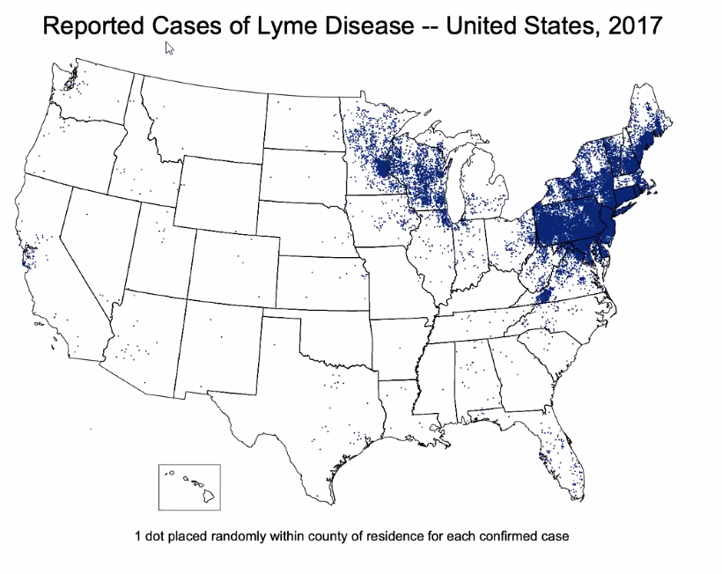

On behalf of the UW TASP Specialist Team:

John Lynch, MD MPH
Chloe Bryson-Cahn, MD
Jeannie Chan, PharmD
Zahra Kassamali Escobar, PharmD
Rupali Jain, PharmD
Paul Pottinger, MD FIDSA

PLEASE NOTE that UW TASP case consultations do not create or otherwise establish a provider-patient relationship between any UW Medicine Health Care Professional and any patient whose case is being presented in a UW TASP setting. A provider-patient relationship between a UW Medicine Health Care Professional and a patient whose case was presented at UW TASP may later be established if the patient is referred and seen in the context of a regular appointment with the UW Medicine Health Care Professional.

