Hospital: Ocean Beach (Ilwaco, WA)
Presenter: Tara Dockery, IP
Question/case summary:
What are the “standards or guidelines” for treating a patient with bacteremia.
PA had a discussion with our Pharmacist yesterday that said once the blood cultures come back negative, the treatment is complete and antibiotics should stop.
We have another Provider (past Medical Director) who believes that the antibiotic treatment should be for two weeks, period, no matter what the cultures say.
Of course I discussed fever, elevated WBC and coinfection with her, but she was just asking generally, suppose there is no fever and normal WBC and no other infection.
She would also like to know if there are standards or guidelines for how often to test – we had one provider who ordered a single blood culture daily until the culture was resulted negative. She wants to know if there is an amount of days/time when you should repeat blood cultures or not.
UW TASP Recommendations:

Questions to determine therapy:

1.) Clinical Assessment:
Is this a Gram-positive or Gram-negative infection?
--Gram-positive organisms
S. aureus: at minimum 14 days and a very clear search for metastatic complications which would warrant longer treatment
S. pneumoniae: 5 days is reasonable (assuming source is pneumonia)
Group A Strep: 5-10 days

--Gram negative organisms (e.g. Enterobacteriaceae like E. coli, K. pneumoniae): 7 days¹

What is the source of infection?
--Endocarditis: Confirm and document blood culture clearance with repeat blood cultures
--68% of Gram-negative bacteremia is related to a urinary source ~10% is related to intra-abdominal source. If this source is controlled, then 7 days is an appropriate duration

Is the patient clinically improved?
Yes: no need to repeat blood cultures (assuming meets criteria above)
No: ongoing fevers +/- leukocytosis, consider repeating blood cultures
2.) Diagnostic Assessment: How often do you need to repeat blood cultures
Initial cultures:
--Obtain, at a minimum 2 sets of blood cultures
--1 set 60-70% sensitivity & difficult to determine if the patient grew a contaminant
--2 sets ~80% sensitivity, 3 sets ~90% sensitivity, 4 sets – negligible increase in diagnostic sensitivity
--Pediatrics: Obtain Anaerobic and Aerobic sets, blood volume is a limitation

Repeating blood cultures:
--If symptoms resolved, pt afebrile, no need to repeat after initial presentation
--If initial positive blood culture with S. aureus, repeat q 24-48h until cultures are negative.
--Need to confirm blood culture clearance clinically in all S. aureus blood stream infections
--If initial positive blood culture non-S. aureus, and patient is clinically improved, then repeating cultures for clearance is unnecessary

3.) Treatment
IV vs. PO
--Highly bioavailable PO agents (i.e. fluoroquinolones) may be used to treat after antimicrobial susceptibility is confirmed and no issues with GI absorption

References:
- Yahav D, Franceschini E, Koppel F, et al. Seven versus fourteen Days of Antibiotic Therapy for uncomplicated Gram-negative Bacteremia: A Non-inferiority Randomized Controlled Trial. Clin Infect Dis. 2018 Dec 11. doi: 10.1093/cid/ciy1054.

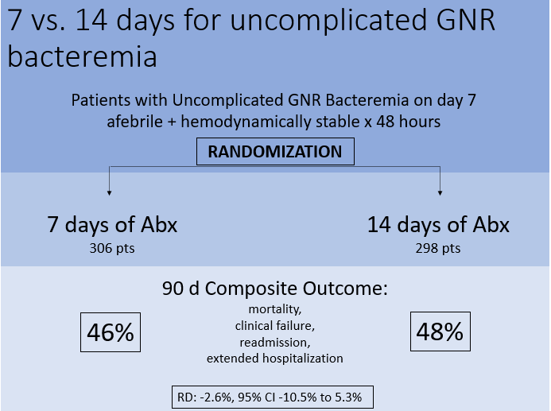

On behalf of the UW TASP Specialist Team:

John Lynch, MD MPH
Chloe Bryson-Cahn, MD
Jeannie Chan, PharmD
Zahra Kassamali Escobar, PharmD
Rupali Jain, PharmD
Paul Pottinger, MD FIDSA

PLEASE NOTE that UW TASP case consultations do not create or otherwise establish a provider-patient relationship between any UW Medicine Health Care Professional and any patient whose case is being presented in a UW TASP setting. A provider-patient relationship between a UW Medicine Health Care Professional and a patient whose case was presented at UW TASP may later be established if the patient is referred and seen in the context of a regular appointment with the UW Medicine Health Care Professional.

