Hospital: Confluence Health
Presenter: Khoa Nguyen
Question/case summary:

Background: IDSA recommends empiric broad spectrum abx with vancomycin + (carbapenem, pip-taz, or ceftriaxone+metronidazole) for necrotizing fasciitis regardless of type (eg. type I,II, III, etc.), BUT only seems to recommend clindamycin when it’s group A strep (toxin and for the eagle effect we talked about last week)

Normally when a patient presents with what appears to necrotizing fasciitis, broad spectrum antibiotics are initiated here mostly of vancomycin + (carbapenem, pip-taz, or ceftriaxone+metronidazole) AND clindamycin

In a 2017 NEMJ by Stevens, this flowchart shows the different breakdown of the types of nec fasc.
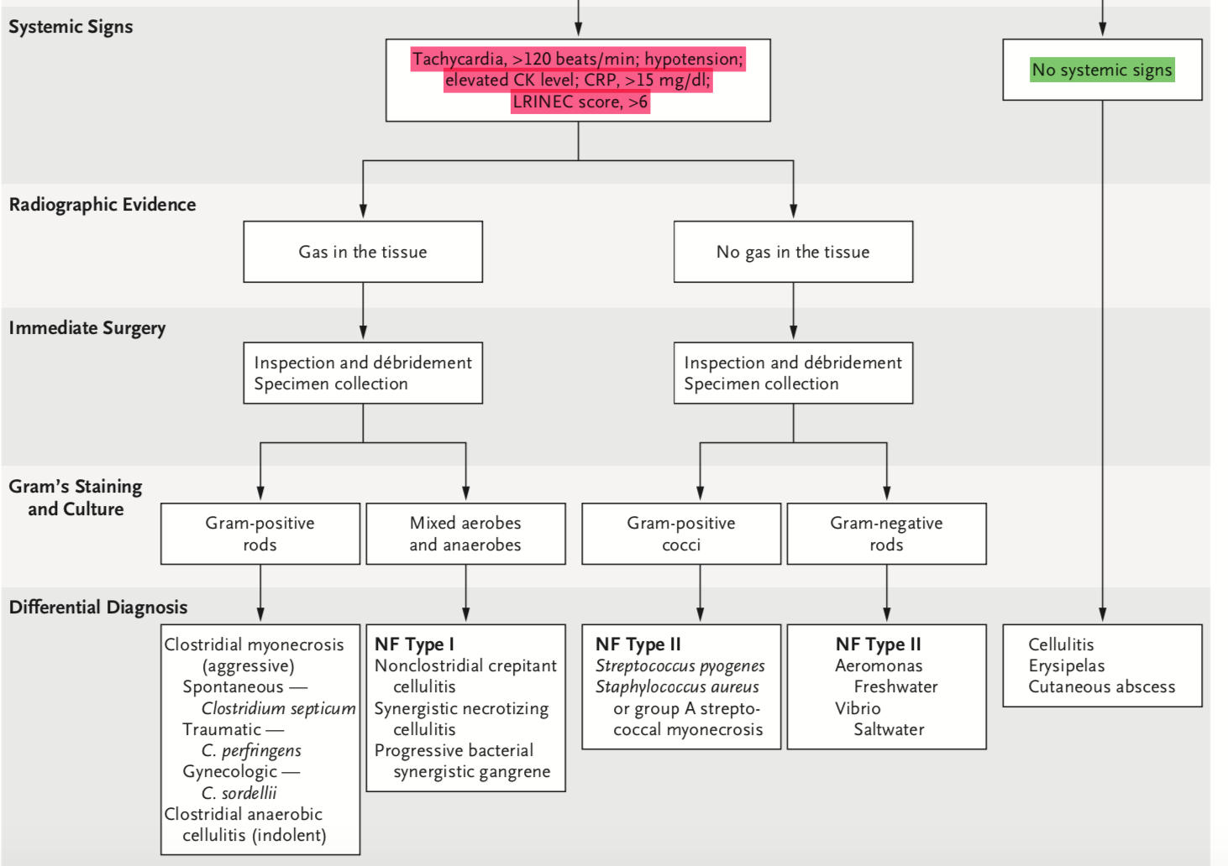

While not directly stated in the guidelines, it makes total sense to empirically give it along with the vanco +broad-spec B-lactam given the urgency of nec fas, especially since clindamycin has been shown to improve outcomes if it is GAS. Bottom line: After staring vanco and a broad-spec b-lactam, should clindamycin empirically be initiated in all nec fasc cases then de-escalated later, or is it safe to wait for the radiographic finding and gram stain to see if staph and strep are likely present?

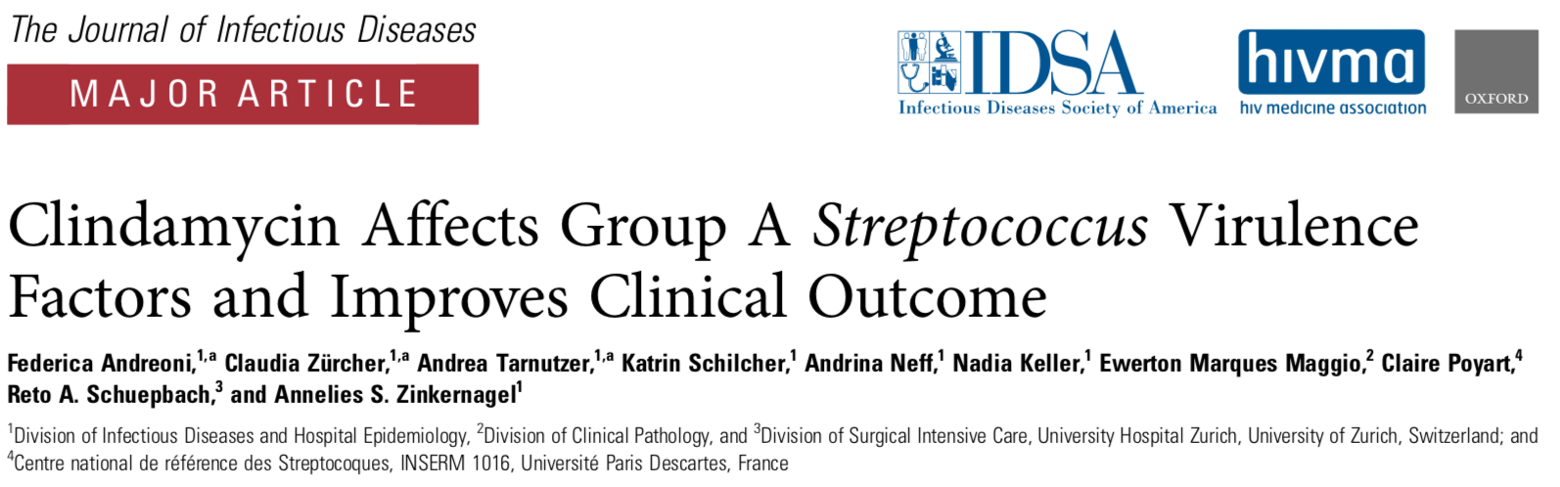

UW TASP Recommendations:

If there is clinical suspicion for necrotizing soft tissue infection (NSTI), clindamycin should be part of the empiric antimicrobial regimen. As the mortality rate is notoriously high with these invasive infections, surgical debridement is paramount in addition to optimization of empiric antibiotics to cover all potential pathogens.
Even when there is radiographic evidence of gas in the tissue, it is often difficult to distinguish between clostridial necrosis vs. Type-1 NSTI which tends to be polymicrobial with both aerobes and anaerobes.
Penicillin and clindamycin in combination are recommended for necrotizing fasciitis due to group A strep (GAS) and clostridial gas gangrene or myonecrosis [1]. Although Group A strep is universally susceptible to penicillin, these deep infections involve the fascial and/or muscle compartments and can potentially lead to life threatening toxic shock syndrome as a complication from invasive group A strep.
In experimental models, Harry Eagle demonstrated that penicillin is most effective during the exponential growth phase of GAS when it is actively multiplying, and the addition of clindamycin by inhibiting bacterial protein synthesis through binding to the 23S RNA of the 50S subunit of the ribosome may further enhance the killing effects of GAS during the stationary phase (see Figure below). Furthermore, clindamycin can suppress streptococcal toxin and cytokine production and inhibits bacterial protein synthesis in addition to the inhibition of cell wall synthesis of penicillin. Animal data suggest clindamycin may be more effective than penicillin against Clostridium perfringens, and thus combination therapy with PCN and clindamycin are often recommended.
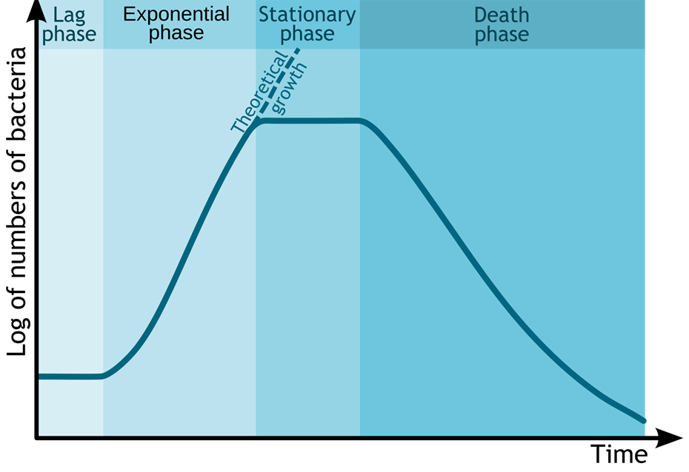

REFERENCE:
- Stevens DL, et al. Practice guidelines for the diagnosis and management of skin and soft tissue infections: 2014 update by the Infectious Disease Society of America. Clin Infect Dis 201415;59(2):e10-52.

On behalf of the UW TASP Specialist Team:

John Lynch, MD MPH
Chloe Bryson-Cahn, MD
Jeannie Chan, PharmD
Zahra Kassamali Escobar, PharmD
Rupali Jain, PharmD
Paul Pottinger, MD FIDSA

PLEASE NOTE that UW TASP case consultations do not create or otherwise establish a provider-patient relationship between any UW Medicine Health Care Professional and any patient whose case is being presented in a UW TASP setting. A provider-patient relationship between a UW Medicine Health Care Professional and a patient whose case was presented at UW TASP may later be established if the patient is referred and seen in the context of a regular appointment with the UW Medicine Health Care Professional.

