- You are running your facility’s SAAR report to see what the All Antibacterial Agent SAAR values look like for your Adult Medical Ward for each quarter of 2022. The report gives you back the following SAAR values:
  - Quarter 1: 1.5
  - Quarter 2: 1.3
  - Quarter 3: 1.0
  - Quarter 4: 0.8
Using the provided cheat sheet, how would you interpret each individual quarter’s SAAR value?

- A hospital wants to assess the impact of their efforts to decrease antifungal agent use for invasive candidiasis in their adult wards. They run the SAAR Report for Quarters 1 – 3 of 2019 and obtain the following results:

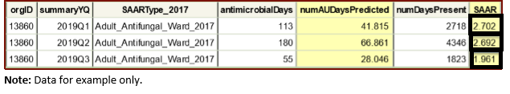
- Were their efforts to decrease antifungal use successful?
- Do these SAAR values tell you if the use of these agents is clinically appropriate?

- You are having a competition in your health system to see who can get their broad-spectrum antibacterial agents predominantly used for hospital-onset infections (BSHO) SAAR value the lowest. The facility administrator runs the report for July 2018 and obtains these results:
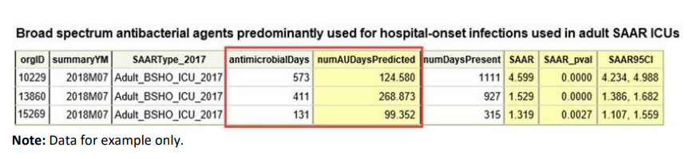
  - Which hospital is “winning” the competition?
  - Do these SAAR values tell you if the use of these agents is clinically appropriate?

- Your facility has identified that Zosyn is being overprescribed as empiric therapy for community-acquired pneumonia in the Adult Medical Ward. Your stewardship team would like to track their progress using the NHSN SAAR report. Which one of the 3 SAAR categories will they look to decrease?
Broad-spectrum antibacterial agents predominantly used for community-acquired infections (BSCA), which groups the following antibiotics:  - Cefaclor  - Cefdinir  - Cefixime  - Cefotaxime  - Cefpodoxime  - Cefprozil  - Ceftriaxone  - Cefuroxime  - Ciprofloxacin  - Ertapenem  - Gemifloxacin  - Levofloxacin  - Moxifloxacin | Broad-spectrum antibacterial agents predominantly used for hospital-onset infections (BSHO), which groups the following antibiotics:  - Amikacin (IV only)  - Aztreonam (IV only)  - Cefepime  - Ceftazidime  - Doripenem  - Gentamicin (IV only)  - Meropenem  - Piperacillin/tazobactam  - Tobramycin (IV only) | Narrow-spectrum beta-lactam agent (NSBL), which groups the following antibiotics:  - Amoxicillin  - Amoxicillin/clavulanate  - Ampicillin  - Ampicillin/sulbactam  - Cefadroxil  - Cefazolin  - Cefotetan  - Cefoxitin  - Cephalexin  - Dicloxacillin  - Nafcillin  - Oxacillin  - Penicillin G  - Penicillin V

