C-Suite Buy-In: Cost Reduction Examples
Jessica Zering, PharmD, BCIDP, BCPS
Antimicrobial Stewardship Pharmacist
Washington State Department of Health

- A stewardship program implemented at the University of Maryland Medical Center lowered its antibiotic costs from $44,181 per 1000 patient-days to $23,933 per 1000 patient-days over 7 years¹

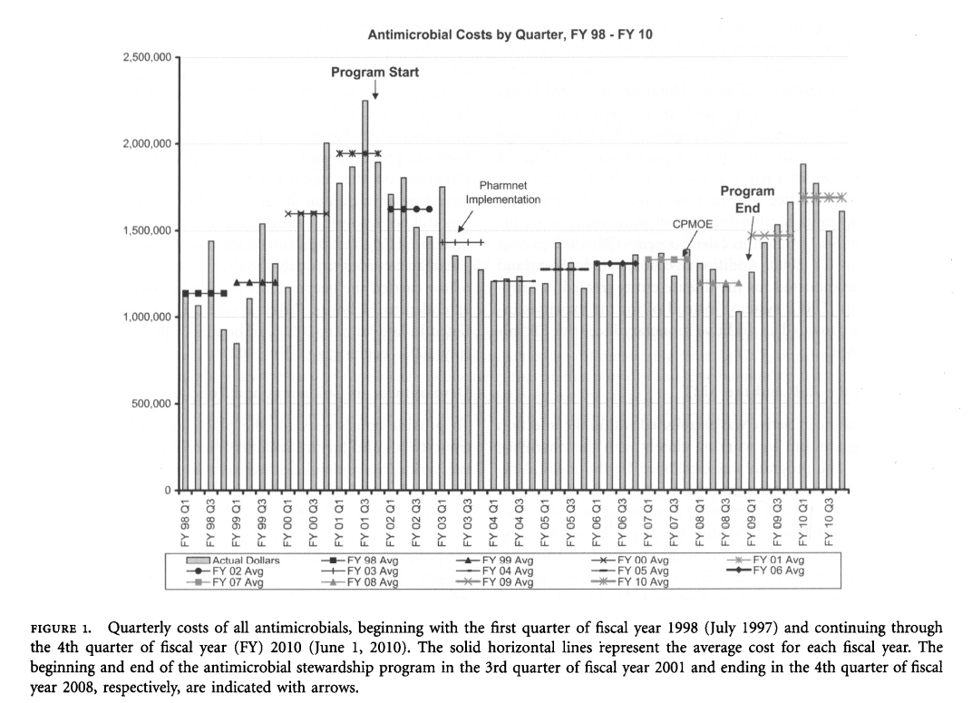

- A stewardship program implemented at Montreal General Hospital lowered yearly antibiotic costs by 46%²

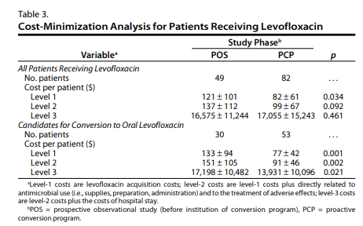
- An IV-to-PO levofloxacin conversion protocol performed over the course of 2 months at Hartford Hospital showed a Level 3 cost savings of close to $3,300 per patient. Median length of stay was also lower in the intervention (PCP) group³

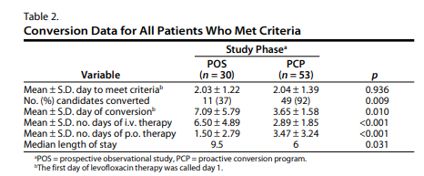

- A penicillin-allergy skin testing protocol completed in 146 patients resulted in a yearly savings of $82,000 at a university teaching hospital

- A program created at Wake Forest Baptist Medical Center showed an average cost savings of $920,070 to $2,064,441 per year. These data are based on total costs spent on antibiotics and do not include the labor costs from the antimicrobial stewardship physician and pharmacist FTEs⁵

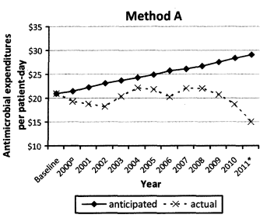
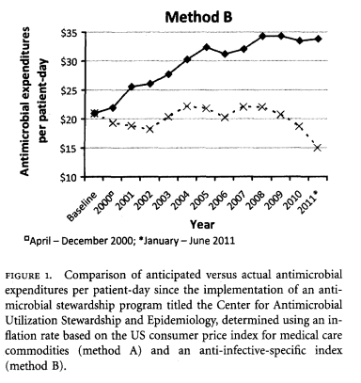

- A diagnostic stewardship intervention focused on C. difficile led to a lab cost savings of $2,017.80 per month. This is based on a cost per test of $34.20. This involved education and the creation of lab criteria for stool sample rejection. With an average of 5 patients/month avoiding oral vancomycin, it was estimated that there was a further average savings of nearly $5,000/month⁶
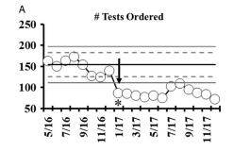
Changes in Clostridium difficile nucleic acid amplification test (NAAT) results over time. (A) = Number of
NAATs ordered per month from May 2016 to December 2017. Intervention was performed beginning Jan 2017

Sources:
- Standiford HC, Chan S, Tripoli M, Weekes E, Forrest GN. Antimicrobial stewardship at a large tertiary care academic medical center: cost analysis before, during, and after a 7-year program. Infection Control and Hospital Epidemiology [Internet]. 2015 Jan 2 [cited 2022 Nov 3];33(4):338–45. Available from: https://pubmed.ncbi.nlm.nih.gov/22418628/
- Lee TC, Frenette C, Jayaraman D, Green L, Pilote L. Antibiotic Self-stewardship: Trainee-Led Structured Antibiotic Time-outs to Improve Antimicrobial Use. Annals of Internal Medicine [Internet]. 2014 Nov 18 [cited 2022 Nov 3];161(10):S53–8. Available from: https://www.acpjournals.org/doi/epdf/10.7326/M13-3016
- Kuti JL, Le TN, Nightingale CH, Nicolau DP, Quintiliani R. Pharmacoeconomics of a pharmacist-managed program for automatically converting levofloxacin route from i.v. to oral. American Journal of Health-System Pharmacy [Internet]. 2002 Nov 15 [cited 2022 Dec 22];59(22):2209–15. Available from: https://academic.oup.com/ajhp/article/59/22/2209/5158031?login=true
- Barlam TF, Cosgrove SE, Abbo LM, MacDougall C, Schuetz AN, Septimus EJ, et al. Implementing an Antibiotic Stewardship Program: Guidelines by the Infectious Diseases Society of America and the Society for Healthcare Epidemiology of America. Clinical Infectious Diseases [Internet]. 2016 Apr 13 [cited 2022 Nov 3];62(10):e51–77. Available from: https://academic.oup.com/cid/article/62/10/e51/2462846
- Beardsley JR, Williamson JC, Johnson JW, Luther VP, Wrenn RH, Ohl CC. Show Me the Money: Long-Term Financial Impact of an Antimicrobial Stewardship Program. Infection Control & Hospital Epidemiology [Internet]. 2012 Apr [cited 2022 Nov 3];33(4):398–400. Available from: https://www.cambridge.org/core/services/aop-cambridge-core/content/view/9E73FC8470A5FDE079B025A87A8032FC/S019594170004128Xa.pdf/show-me-the-money-long-term-financial-impact-of-an-antimicrobial-stewardship-program.pdf
- Yen C, Holtom P, Butler-Wu SM, Wald-Dickler N, Shulman I, Spellberg B. Reducing Clostridium difficile Colitis Rates Via Cost-Saving Diagnostic Stewardship. Infection Control & Hospital Epidemiology [Internet]. 2018 Apr 3 [cited 2022 Dec 22];39(6):734–6. Available from: https://www.cambridge.org/core/journals/infection-control-and-hospital-epidemiology/article/reducing-clostridium-difficile-colitis-rates-via-costsaving-diagnostic-stewardship/D6791B795662C8479CACF1C1DE18D345

To request this document in another format, call 1-800-525-0127. Deaf or hard of hearing customers, please call 711 (Washington Relay) or email civil.rights@doh.wa.gov.
This document does not replace clinical judgement

